Created Two threads

MulthiThread.java

**package** com.db.awmd.challenge.domain;

**import** java.math.BigDecimal;

**import** java.util.Arrays;

**import** org.springframework.http.HttpEntity;

**import** org.springframework.http.HttpHeaders;

**import** org.springframework.http.HttpMethod;

**import** org.springframework.http.MediaType;

**import** org.springframework.web.client.RestTemplate;

**public** **class** Multithread **extends** Thread{

**public** **void** run()

{

**try**

{

// Displaying the thread that is running

System.***out***.println ("Thread " +

Thread.*currentThread*().getId() +

" is running");

RestTemplate restTemplate= **new** RestTemplate();

HttpHeaders headers = **new** HttpHeaders();

headers.setAccept(Arrays.*asList*(MediaType.***APPLICATION_JSON***));

TransactionDetails swetaTransaction=**new** TransactionDetails("sweta", "narendra", **new** BigDecimal(100));

HttpEntity<TransactionDetails> entity = **new** HttpEntity<TransactionDetails>(swetaTransaction,headers);

restTemplate.exchange(

"http://localhost:18080/v1/accounts/amount/transfer", HttpMethod.***POST***, entity, String.**class**).getBody();

/*

*

* TransactionDetails nTransaction=new TransactionDetails( "narendra","sweta",

* new BigDecimal(10));

*

*

* HttpEntity<TransactionDetails> entity2 = new

* HttpEntity<TransactionDetails>(nTransaction,headers); restTemplate.exchange(

* "http://localhost:18080/v1/accounts/amount/transfer", HttpMethod.POST,

* entity2, String.class).getBody()

*/;

}

**catch** (Exception e)

{

// Throwing an exception

System.***out***.println ("Exception is caught");

}

}

}

MultiThread2.java

**package** com.db.awmd.challenge.domain;

**import** java.math.BigDecimal;

**import** java.util.Arrays;

**import** org.springframework.http.HttpEntity;

**import** org.springframework.http.HttpHeaders;

**import** org.springframework.http.HttpMethod;

**import** org.springframework.http.MediaType;

**import** org.springframework.web.client.RestTemplate;

**public** **class** MultiThead2 **extends** Thread{

**public** **void** run()

{

**try**

{

// Displaying the thread that is running

System.***out***.println ("Thread " +

Thread.*currentThread*().getId() +

" is running");

RestTemplate restTemplate= **new** RestTemplate();

HttpHeaders headers = **new** HttpHeaders();

headers.setAccept(Arrays.*asList*(MediaType.***APPLICATION_JSON***));

/*

* TransactionDetails swetaTransaction=new TransactionDetails("sweta",

* "narendra", new BigDecimal(100));

*

*

* HttpEntity<TransactionDetails> entity = new

* HttpEntity<TransactionDetails>(swetaTransaction,headers);

* restTemplate.exchange( "http://localhost:18080/v1/accounts/amount/transfer",

* HttpMethod.POST, entity, String.class).getBody();

*

*/

TransactionDetails nTransaction=**new** TransactionDetails( "narendra","sweta", **new** BigDecimal(10));

HttpEntity<TransactionDetails> entity2 = **new** HttpEntity<TransactionDetails>(nTransaction,headers);

restTemplate.exchange(

"http://localhost:18080/v1/accounts/amount/transfer", HttpMethod.***POST***, entity2, String.**class**).getBody();

}

**catch** (Exception e)

{

// Throwing an exception

System.***out***.println ("Exception is caught");

}

}

}

AccountController.java

@GetMapping(path = "/test/thread")

**public** **void** testThread() {

RestTemplate restTemplate= **new** RestTemplate();

HttpHeaders headers = **new** HttpHeaders();

headers.setAccept(Arrays.*asList*(MediaType.***APPLICATION_JSON***));

Account swetaAccount=**new** Account("sweta", **new** BigDecimal(100000));

Account narendraAccount=**new** Account("narendra", **new** BigDecimal(0));

HttpEntity<Account> entity = **new** HttpEntity<Account>(swetaAccount,headers);

restTemplate.exchange(

"http://localhost:18080/v1/accounts", HttpMethod.***POST***, entity, String.**class**).getBody();

HttpEntity<Account> entity2 = **new** HttpEntity<Account>(narendraAccount,headers);

restTemplate.exchange(

"http://localhost:18080/v1/accounts", HttpMethod.***POST***, entity2, String.**class**).getBody();

**int** n = 100; //number of threads

**for** (**int** i=0; i<n; i++)

{

Multithread object = **new** Multithread();

object.start();

MultiThead2 object1 = **new** MultiThead2();

object1.start();

}

}

Start the server :

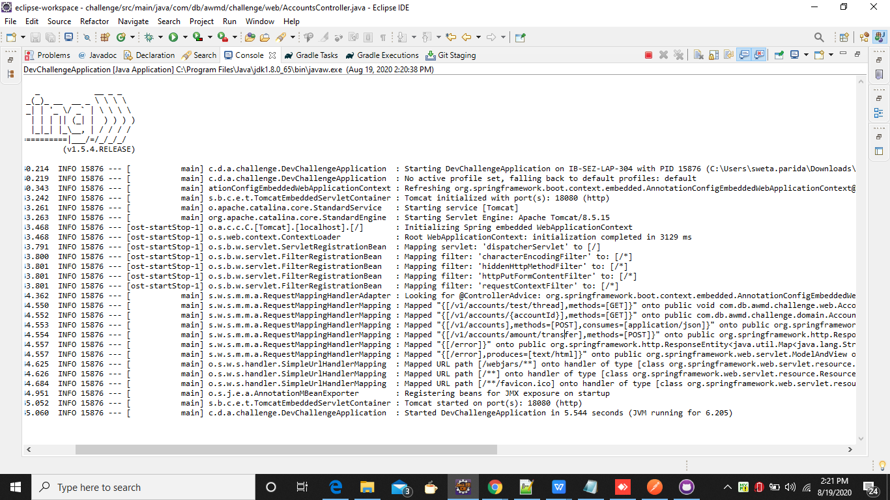

From the postman :

POST : - http://localhost:18080/v1/accounts/test/thread

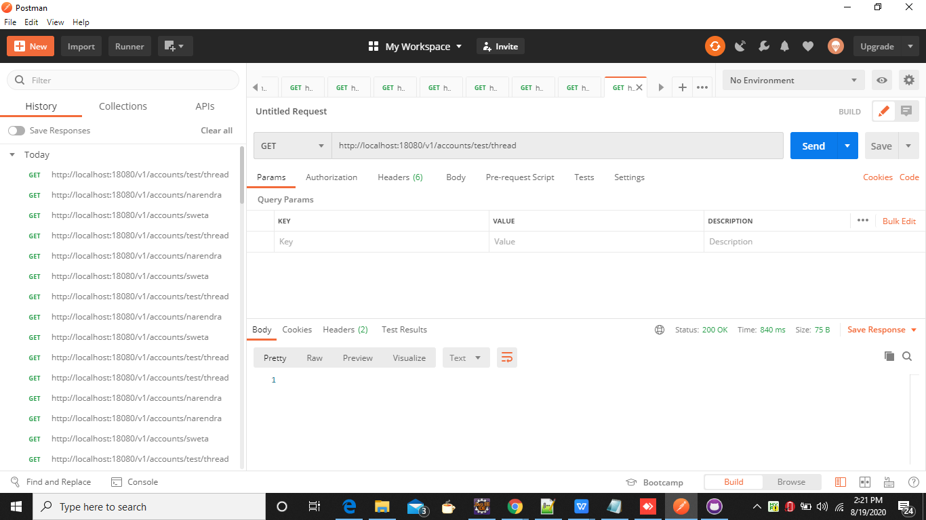

Checking the Account 1 balances : - **<http://localhost:18080/v1/accounts/sweta>**

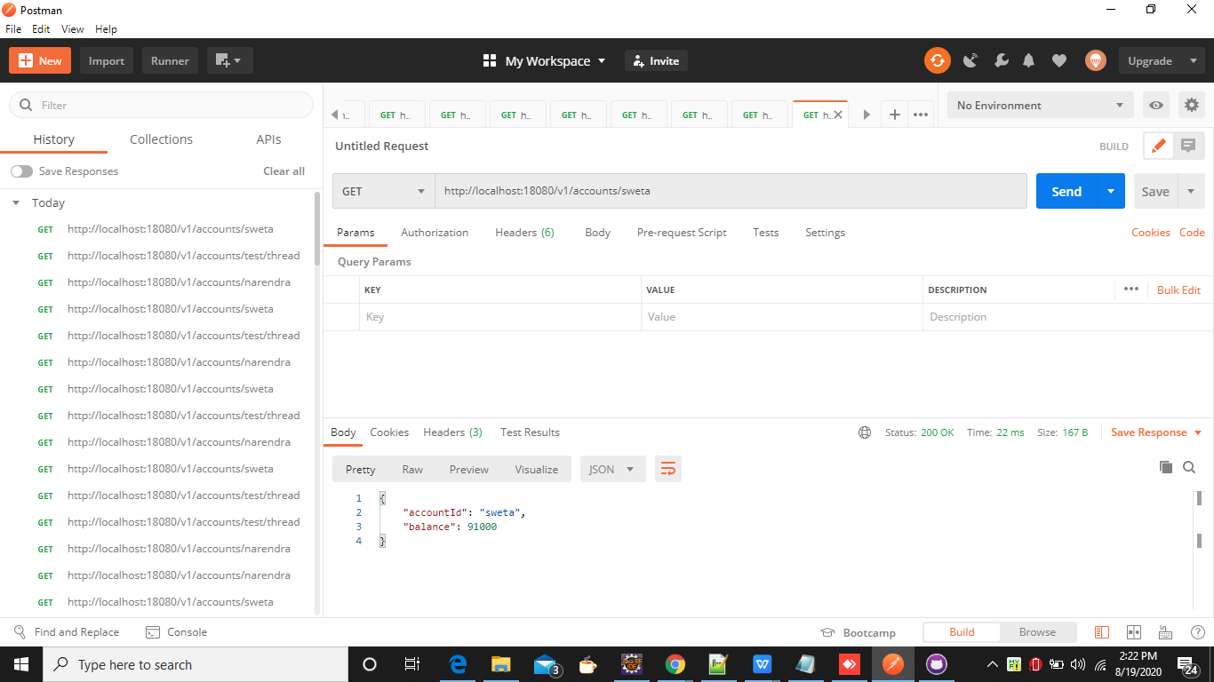

Checking the Account 2 Balances : - **http://localhost:18080/v1/accounts/narendra**

